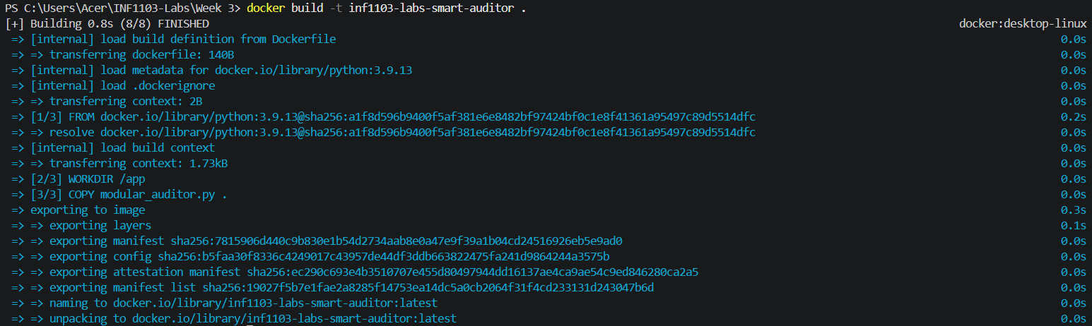
Docker build
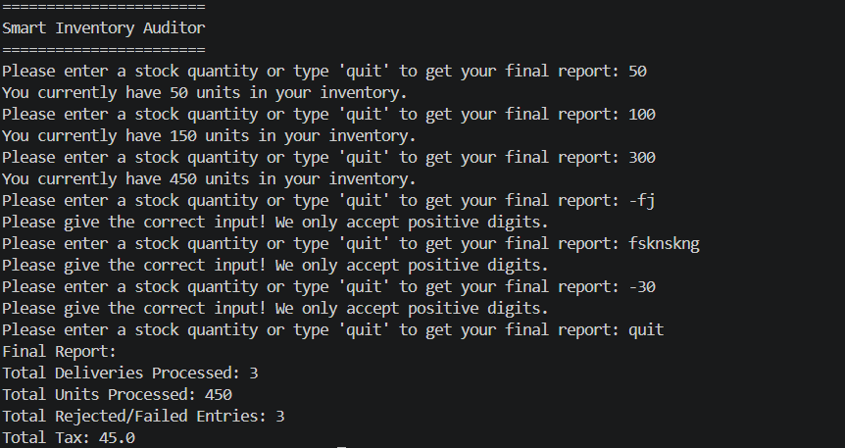
Docker run
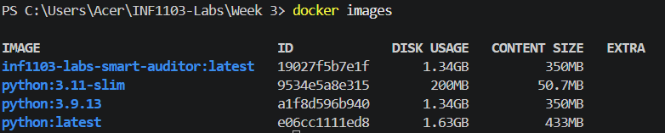
Docker images

